**LEARNING MANAGEMENT SYSTEM**

**MINI PROJECT REPORT**

**18CSC311J – WEB DESIGN AND DEVELOPMENT LABORATORY**

**(2018 Regulation)**

# Year/ VI Semester

**Academic Year: 2022 -2023**

By

**<<R Chitranshi – RA2111028010084>>**

**<<K.V.S.Sathvik – RA2111028010078>>**

Under the guidance of

**<< Dr.Sundarrajan M>>**

# Assistant Professor Department of Networking and Communications



**DEPARTMENT OF NETWORKING AND COMMUNICATIONS**

**FACULTY OF ENGINEERING AND TECHNOLOGY SRM INSTITUTE OF SCIENCE AND TECHNOLOGY Kattankulathur, Kancheepuram MAY 2023**

# BONAFIDE

Certified that this Mini project report titled “**Learning Management System**” for the course

**18CSC311J – WEB DESIGN AND DEVELOPMENT LABORATORY** is the bonafide

work of **<R Chitranshi(RA2111028010084)(K.V.S Sathvik(RA2111028010078)>** who undertook the task of completing the project within the allotted time.

|  |  |
| --- | --- |
| **Signature** | **Signature** |
| Dr. Sundarrajan M | Dr. Annapurani Panaiyappan K |
| **Course Faculty** | **Head of the Department** |
| Assistant Professor | Professor |
| Department of NWC | Department of NWC |

# Abstract

In today's digital age, the demand for effective and efficient educational tools is ever-growing. A Learning Management System (LMS) emerges as a pivotal solution in meeting these demands by providing a comprehensive platform for managing, delivering, and tracking educational content and activities. This abstract explores the key features and benefits of an LMS, highlighting its role in enhancing education across various sectors.

The LMS serves as a centralized hub, enabling educators to create, organize, and deliver engaging learning experiences tailored to the needs of diverse learners. It offers a range of functionalities, including course management, user administration, assessment and grading, communication tools, analytics, and mobile compatibility. Through these features, educators can design dynamic courses, monitor learner progress, facilitate communication and collaboration, and analyze data to optimize teaching and learning outcomes.

Furthermore, the flexibility and accessibility of an LMS empower learners to engage with educational content at their own pace and convenience, fostering a more personalized and interactive learning experience. Whether in traditional classroom settings, online courses, or corporate training programs, the LMS enables seamless delivery of educational content, transcending geographical and temporal barriers.

In conclusion, the adoption of a Learning Management System represents a transformative step towards enhancing education by harnessing the power of technology to facilitate learning, empower educators, and enrich the learning experience for all stakeholders involved.

# Table of Contents

**Chapter No. Chapter Name Page Number**

Abstract

1. Introduction
   1. About the Web application
   2. Existing Web application
2. System Architecture
3. Website Front End Implementation
   1. Tools used
   2. Web Page Design
   3. Screenshots
4. Website Backend Implementation
   1. Tools used
   2. Code for backend
5. Database Design
   1. Database used
   2. Database schema and Tables used in the Project
6. Screen shots
7. Conclusion and Future Work

References

# CHAPTER 1 INTRODUCTION

* 1. **About the Web Application:**

A platform or software application called a Learning Management System (LMS) is used to organize, conduct, and monitor training sessions and courses. It acts as a central location for arranging course materials, conducting exams, and promoting interaction between teachers and students. LMS systems are extensively utilized in a variety of educational contexts, such as online learning environments, organizations, colleges, and schools Setting up the system architecture, creating user accounts, creating course templates, and integrating lectures, videos, quizzes, and assignments are all common steps in the launch of an LMS. The LMS may be tailored by administrators to meet the unique requirements and objectives of their school or organization, giving them control over how courses are taught and how they are assessed.

* 1. **Existing Web Applications:**

Learning management systems (LMS) are digital platforms designed to facilitate the management, delivery, and tracking of educational content and activities. They serve as centralized hubs for organizing course materials, administering assessments, facilitating communication between instructors and learners, and tracking learner progress.Examples of popular learning management systems include Moodle, Canvas, Blackboard Learn, Schoology, and Google Classroom. Each LMS offers a range of features such as course management, content creation and delivery, assessment tools, communication tools, analytics, and mobile compatibility.

* 1. **List of popular learning management systems**:

**Moodle:**

Moodle is an open-source learning platform widely used in educational institutions, corporations, and non-profit organizations. It offers a range of features such as course management, quizzes, assignments, grading, forums, and analytics. Moodle is highly customizable and supports a large community of developers and users who contribute to its ongoing development.

**Canvas:**

Canvas is a cloud-based LMS developed by Instructure. It is known for its user-friendly interface, mobile compatibility, and extensive integration capabilities with third-party tools and services. Canvas offers features such as course design, communication tools, assessments, analytics, and collaboration features.

**Blackboard Learn:**

Blackboard Learn is a comprehensive learning management system used by educational institutions worldwide. It provides tools for course creation, content management, assessments, discussion boards, and grading. Blackboard Learn also offers advanced features such as adaptive learning, virtual classrooms, and mobile apps.

**Schoology:**

Schoology is a learning management system designed for K-12 schools and districts. It offers features such as course management, assessments, discussions, messaging, and collaboration tools. Schoology focuses on providing a user-friendly interface and intuitive design to support both teachers and students in their educational journey.

**Google Classroom:**

Google Classroom is a free LMS developed by Google for schools and educational institutions. It integrates seamlessly with other Google Workspace (formerly G Suite) apps such as Google Drive, Docs, and Calendar. Google Classroom simplifies the process of creating, distributing, and grading assignments, and facilitates communication and collaboration between teachers and students.

.

**1.4 Drawbacks of existing application:**

While learning management systems (LMS) offer numerous benefits, they also come with certain drawbacks. Here are some common drawbacks associated with LMS:

**Steep Learning Curve:**

Some learning management systems can have a complex interface and feature set, making it challenging for users, particularly educators who may not be tech-savvy, to navigate and utilize all functionalities effectively.

**Limited Customization:**

Despite offering customization options, some LMS platforms

may have limitations in terms of tailoring the interface and features to meet the specific needs and preferences of educators and learners. This can lead to a lack of flexibility in course design and delivery.

**Cost:**

Implementing and maintaining an LMS can be costly, especially for smaller educational institutions or organizations with limited budgets. Licensing fees, infrastructure costs, customization expenses, and ongoing support and maintenance can add up over time.

**Technical Issues:**

Like any software, LMS platforms may encounter technical glitches, bugs, or downtime, which can disrupt the learning experience and cause frustration for users. Issues related to compatibility with different devices and browsers can also arise.

**Content Accessibility:**

Ensuring that learning materials are accessible to all learners, including those with disabilities, can be challenging in some LMS platforms. Designing content with accessibility features such as screen reader compatibility and alternative text for images may require additional effort.

**Data Security and Privacy Concerns:**

LMS platforms handle sensitive information such as student data, grades, and assessment results. Ensuring the security and privacy of this data, including protection against unauthorized access or data breaches, is paramount but can be challenging, especially with the increasing risk of cyber threats.

**Over-reliance on Technology:**

While LMS platforms offer valuable tools for managing and delivering educational content, there is a risk of over-reliance on technology, which may detract from more personalized and interactive forms of teaching and learning. It's essential to strike a balance between utilizing technology and maintaining human interaction in the learning process.

**Resistance to Change:**

Introducing a new LMS or transitioning from traditional teaching methods to online learning can face resistance from educators, learners, and administrators who may be accustomed to established practices. Overcoming resistance to change and ensuring buy-in from all stakeholders is essential for successful implementation.

Top of Form

**1.5 Project Objectives:**

**Enhancing Accessibility**: Ensure that educational materials are easily accessible to all learners, regardless of their location, schedule, or physical abilities.

**Improving Efficiency**: Streamline administrative tasks such as course creation, enrollment, grading, and reporting, to save time and resources for educators and administrators.

**Facilitating Collaboration**: Foster collaboration and communication among educators, learners, and other stakeholders through discussion forums, messaging, and collaborative activities.

**Personalizing Learning**: Provide personalized learning experiences by offering adaptive learning paths, tailored content recommendations, and individualized feedback based on learners' needs and preferences.

**Increasing Engagement**: Engage learners through interactive multimedia content, gamification elements, and social learning features to promote active participation and motivation.

**Enhancing Assessment**: Implement a variety of assessment tools such as quizzes, assignments, polls, and surveys to evaluate learners' progress, knowledge retention, and skill development effectively.

**Monitoring Progress**: Enable educators to track learners' progress, monitor their participation and performance, and identify areas for improvement through analytics and reporting tools.

**Supporting Professional Development**: Offer professional development opportunities for educators to enhance their teaching skills, technology proficiency, and understanding of pedagogical best practices related to online learning.

**Ensuring Compliance**: Ensure compliance with regulatory requirements, institutional policies, and industry standards related to data security, privacy, accessibility, and intellectual property rights.

**Evaluating Effectiveness**: Continuously evaluate the effectiveness of the LMS implementation in achieving educational goals, improving learning outcomes, and enhancing the overall teaching and learning experience for all stakeholders.

**CHAPTER2 SYSTEMARCHITECTURE**

* 1. **System Architecture:**

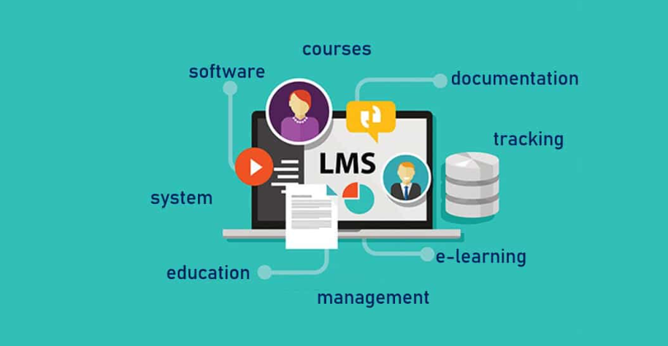

\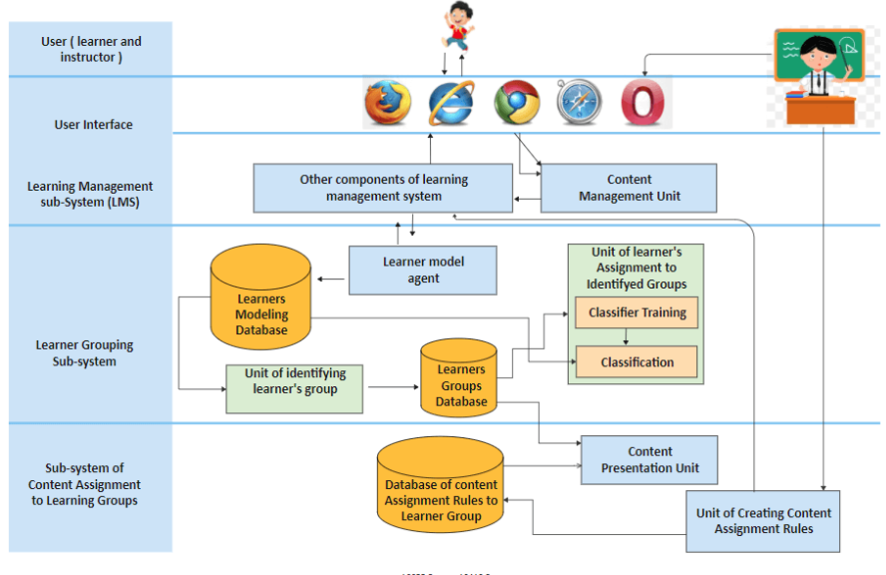

* 1. **Use Case Diagram:**

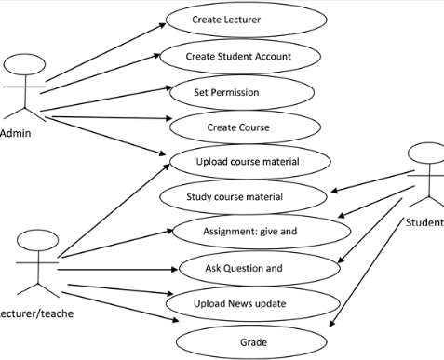

* 1. **Activity Diagram:**

